Attachment 1

Brief introduction for Guangdong Provincial People's Hospital (Guangdong Academy of Medical Sciences)

Guangdong Provincial People's Hospital (Guangdong Academy of Medical Sciences, GAMS) was founded in 1946. With unremitting efforts of several generations of hospital staff, the hospital has developed into a well-known Grade-III Class-A (highest rating in Chinese medical system) hospital, with a comprehensive set of specialties and advanced technologies. Our medical treatment, medical education and scientific research have been developing in an all-round way, with medical technology enjoying a high reputation at home and abroad.
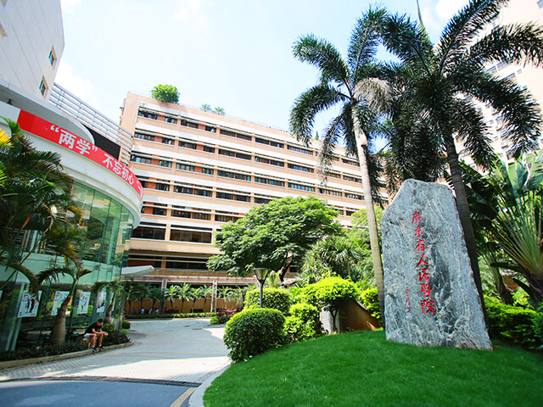
In recent years, GAMS has embarked on a fast lane of high-quality development in the construction of a high-level hospital. High-level talents have been introduced in the hospital to pool medical talents. There are a total of 15 outstanding talents in the hospital, including Changjiang Scholars (a honorable title granted to established professors by the Ministry of Education), winners of The National Science Fund for Distinguished Young Scholars, Excellent Young Scientists Fund, and National Science Fund for Excellent Young Scholars (Overseas). The hospital has won 5 items of first prize of Provincial Scientific and Technological Achievement Awards. In 2021, it had 80 projects of the National Natural Science Foundation of China, which is at a record high and has made a breakthrough of doubling year-on-year and tripling in two years.

In the future, GAMS will continue to forge ahead with international vision, strategic perspective, forward-looking planning and down-to-earth spirit, to work together to promote the construction of a high-level hospital and draw a new strategic blueprint for high-quality development!

