程控交换机技术参数及接口：
NEAX SV9500 电话接口以及数字接口传输接口参数

2.1 系统组织网络结构

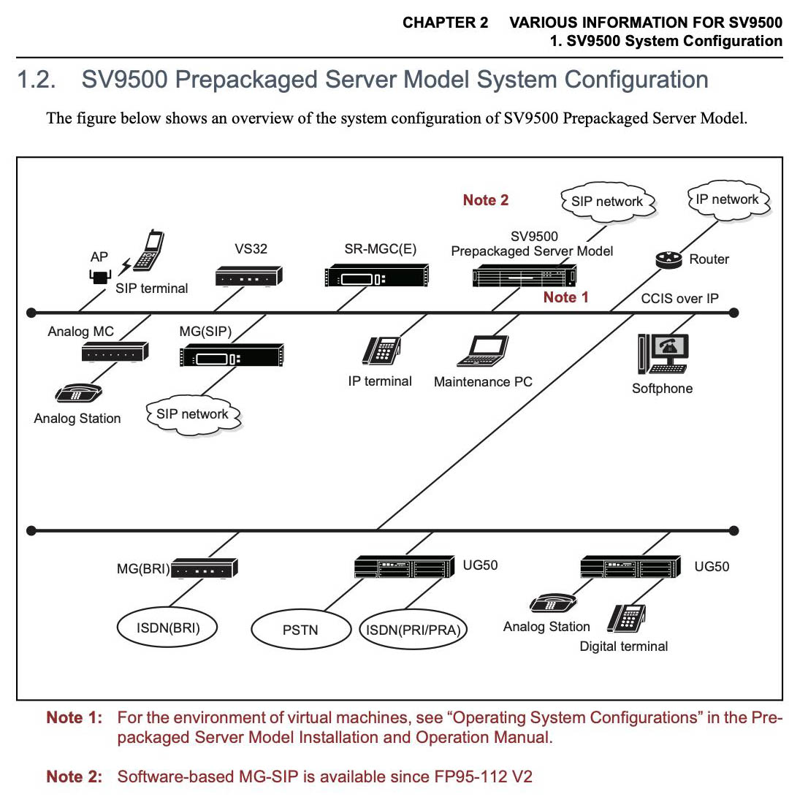

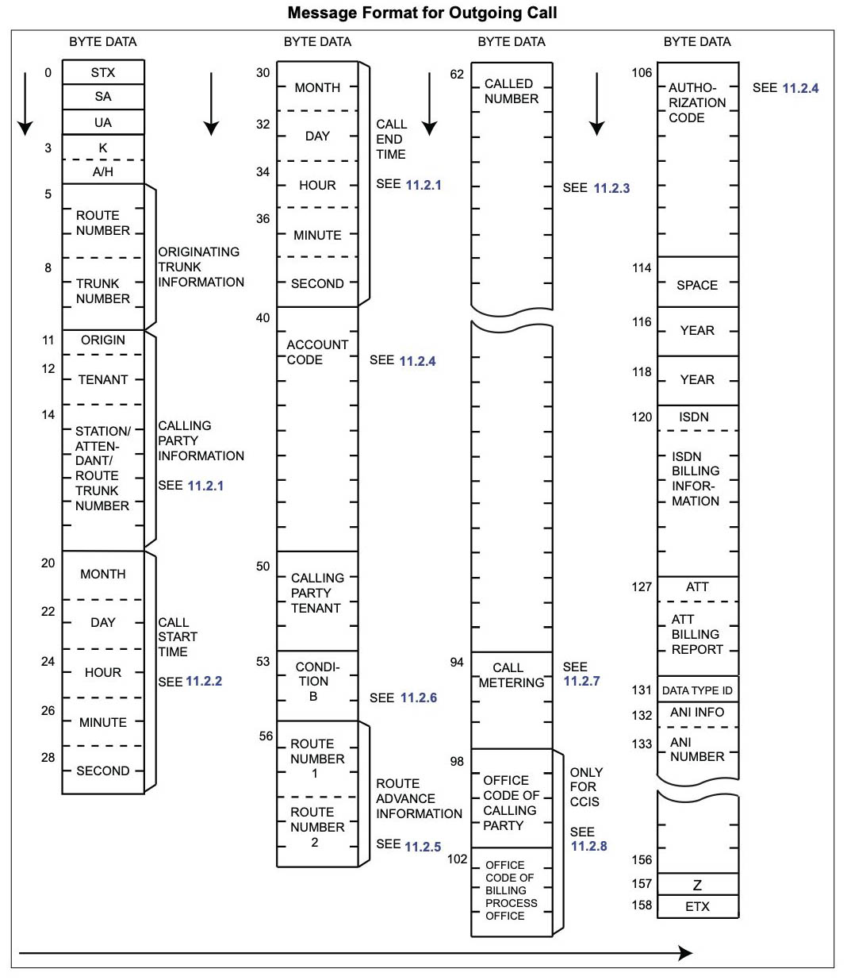

2.2程控交换机数据传送握手信号

Transmit Sequence
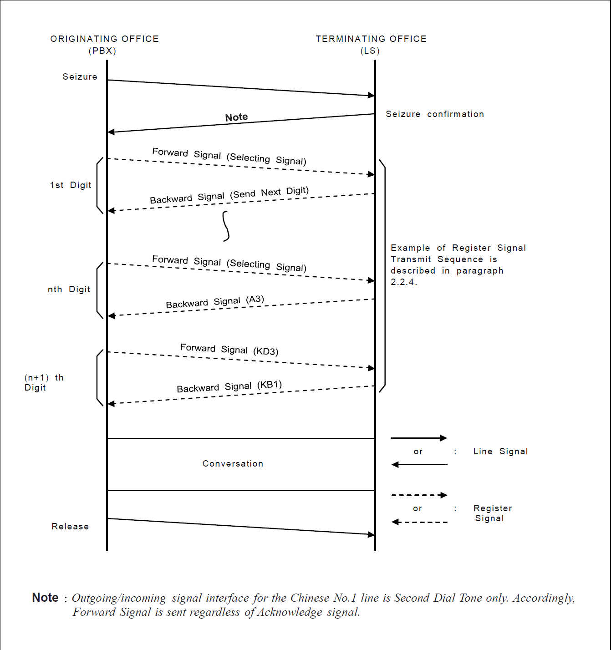

Digital Interface Frame Configuration

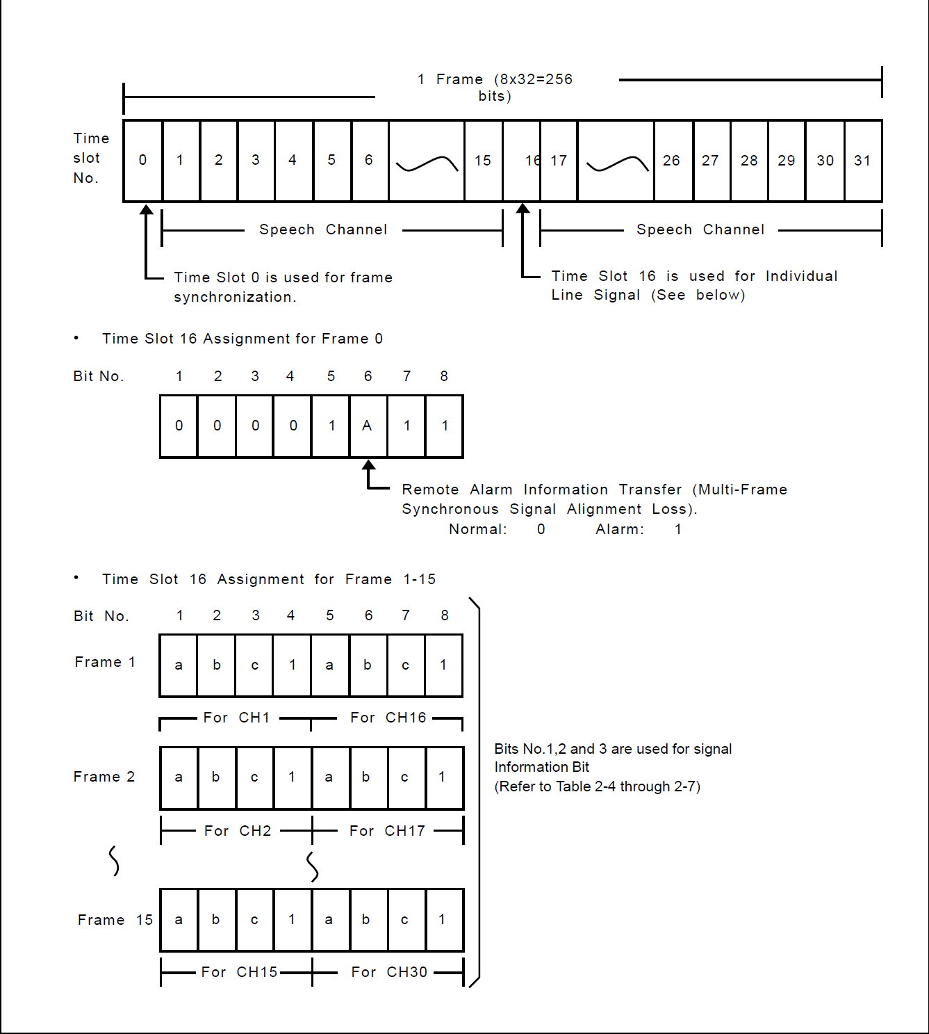

2.3远端模块接入系统信号参数

Digital Signal Coding of Line Signal (Local Call)

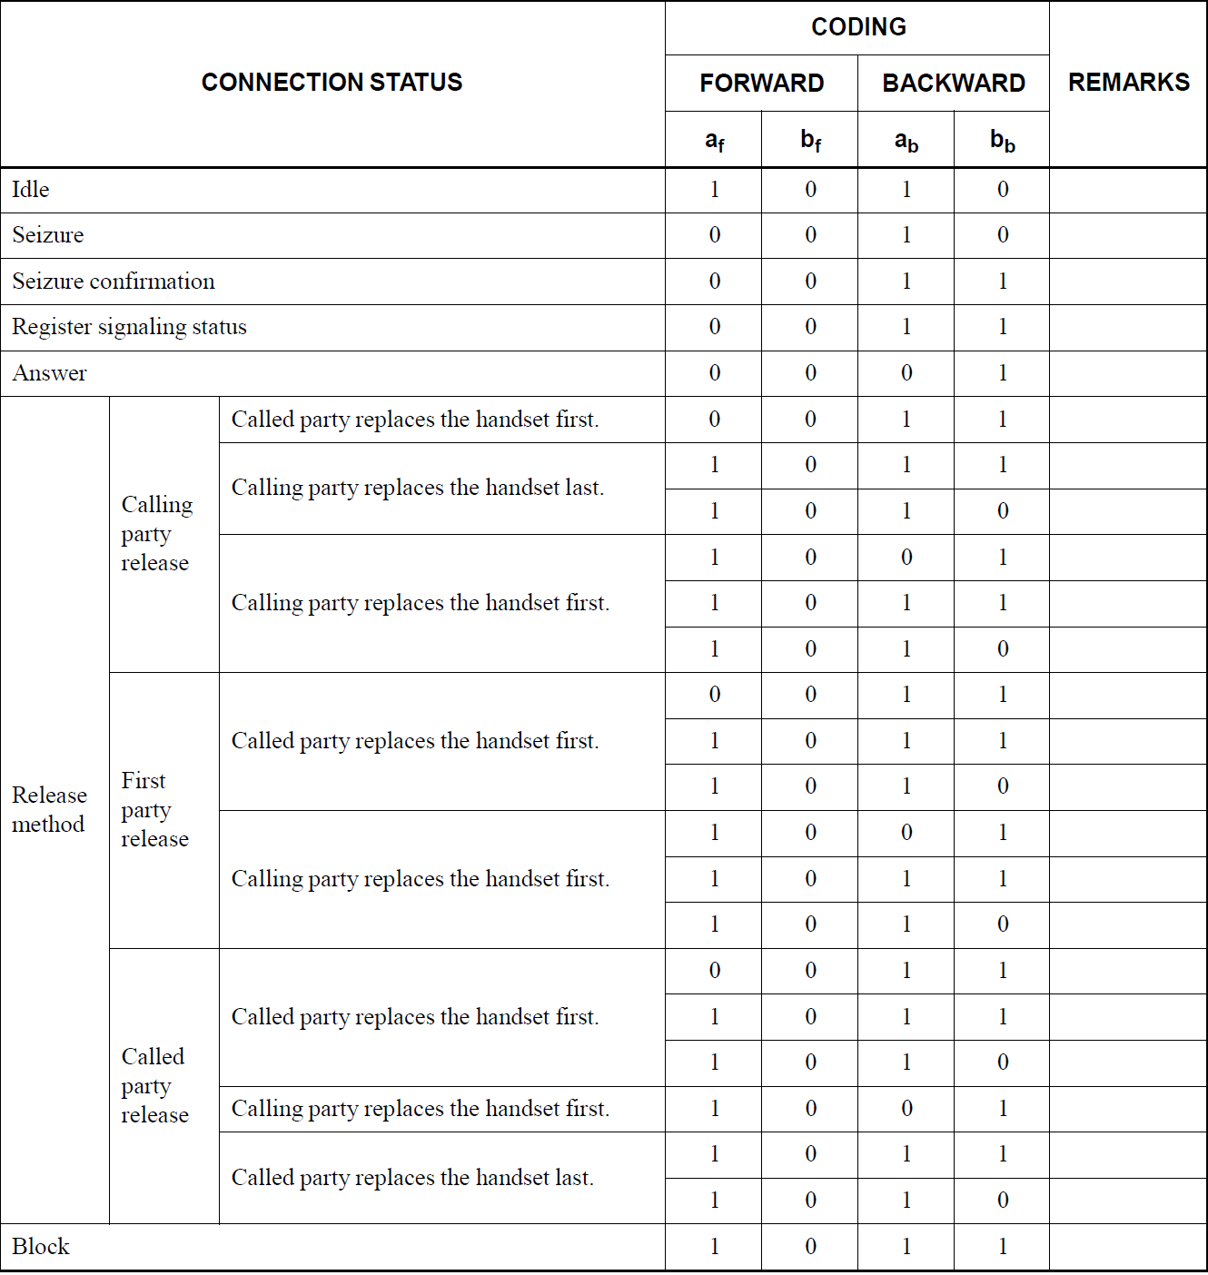
Digital Signal Coding of Line Signal(Toll/International Call-Automatic Outgoing)

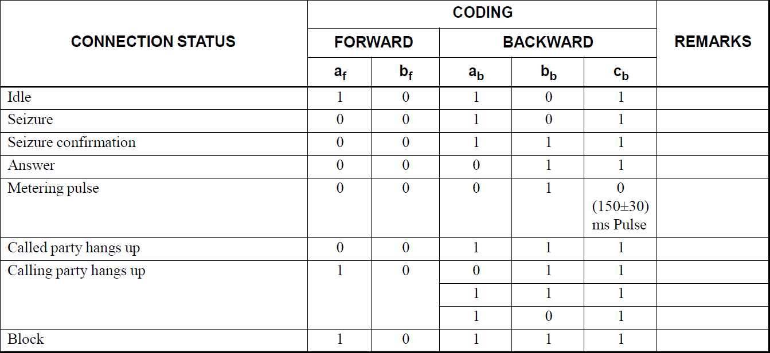
Digital Signal Coding of Line Signal(Toll/international Call-Semi
Automatic/Manual Outgoing)

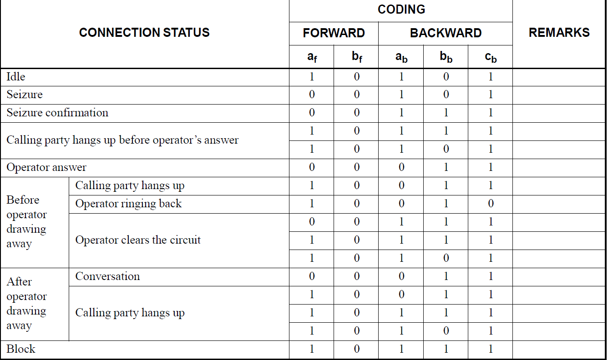

Digital Signal Coding of Line Signal (Toll/International Call-Incoming
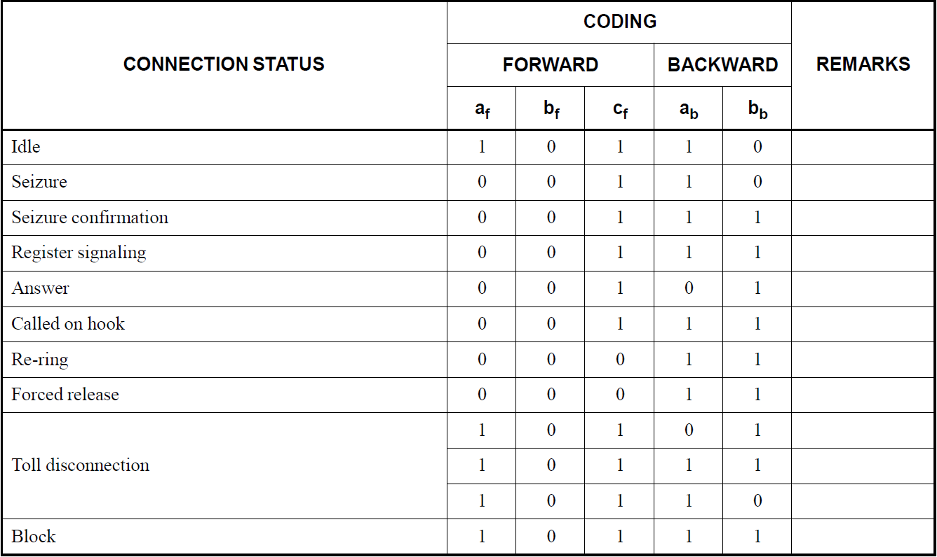
2.4模块分机线路接入交换机需要满足的指标参数
